

INFO FLASH

WQTA

No. 5

102-183 Freeman street, Gatineau, Qc. J8Z 2A7 – Tel.: (819) 7771475 fax: (819) 777-0016

**PROFESSIONAL IMPROVEMENT COMMITTEE**

The purpose of PIC is to lighten the financial burden for those seeking professional development to better their abilities as teachers. This parity committee stems from our Provincial Entente and consists of six members, three representing the WQSB and three representing the WQTA.

The MELS allocates $240 per full-time teacher equivalent to the PIC fund. Unfortunately, this small amount does not cover the registration fee to most conferences. This is why we pool all the money into a centralized fund for the Greater Gatineau Area (Region 7) which is managed by the parity committee. Our three northern schools, Golden Valley, Noranda, and G.Théberge (Region 8) each manage their own allocations.

The PIC year, which begins July 1st, is divided into 4 terms plus an allotment for QPAT Convention in order to ensure that funds are available throughout. The committee considers applications on a first apply, first serve basis. The maximum possible reimbursement for a single teacher is $1400 despite the tiny $240 allocation. This means that it’s only possible to spend $1000+ on an activity because you are in fact using parts of other teachers’ allocation. This is why any PIC activity must be directly related to your teaching assignment.

* When applying for a conference, workshop or a course, please print the form (2 pages) from the WQTA website if they are not available in your staff room, read ALL the instructions, complete, and fax it in to the WQTA office along with a prospectus. Don’t forget to factor in the cost of supply teacher (based on the number of workload minutes) and have your principal sign your application.

* If your application is approved, you will be notified with a confirmation via fax or email.

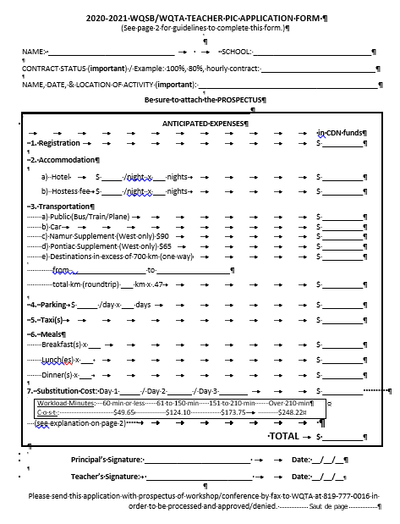 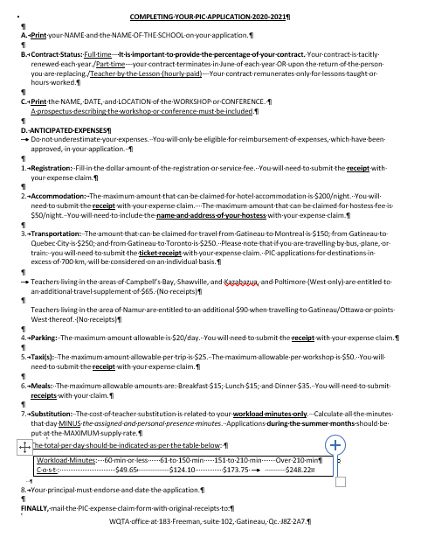

WQTA INFO FLASH NO. 5 / PROFESSIONAL IMPROVEMENT COMMITTEE / PAGE 2

* Within 30 days after the activity, complete a claim form (on the WQTA website) and mail it, along with original receipts, to the WQTA office with sufficient postage. Be sure to follow the instructions on the reverse side of the expense claim form. The WQTA then reviews the claim and sends it to the board for payment. Please remember that a hotel reservation receipt must show a balance of $0. If you have direct deposit (you have sent the WQTA a void cheque), the monies will be deposited into your account. Otherwise, you will receive a cheque by mail so ensure your address is up to date.

* Should you decide to not attend an activity, for which approval has been granted, please notify the WQTA so the funds may be released to someone else.

* Currently, there is a possibility of reimbursement of up to $750 for credit courses. These courses must relate directly to your current teaching workload and a prospectus must accompany your application. Please note that reimbursement can only be made once the WQTA receives confirmation of your successful completion of the course. An official transcript is required.

* If a workshop is sponsored by the WQSB or by the MEQ, then the PIC will not cover any expenses as these have been taken into consideration by the sponsor.

